- What is HTML?
- HTML stands for Hypertext Markup Language.
- A standard markup language, use to create any web page.
- It describes the structure of a web page.
Example 1:
<!DOCTYPE html>
<html>
<head>
<title>Title of the Webpage</title>
</head>
<body>
<h1>This is my first HTML code.</h1>
<p>Hello HTML.</p>
</body>
</html>
Explanation:
- <!DOCTYPE html>: It is use for denoting that the HTML version which we are using is HTML5.
- <html>: It is the starting tag of the html code.
- <head>: It shows the meta info about the webpage
- <title>: It is the Title tag, use for giving the title of the web page. Here the title of the web page is “Title of the Webpage”
- <body>: From here the body part of the web page is start.
- <h1>: This tag is also known as Heading tag. It is use for denoting that the text written in between the tag is a heading, there are total 6 different heading tag are present in the HTML. They are h1, h2, h3, h4, h5, h6 respectively. The font size is gradually decreasing from h1 to h6 respectively.
- <p>: This tag is known as paragraph tag. It is use for denoting that the text written in between the p tag is a paragraph.

Output:
Title
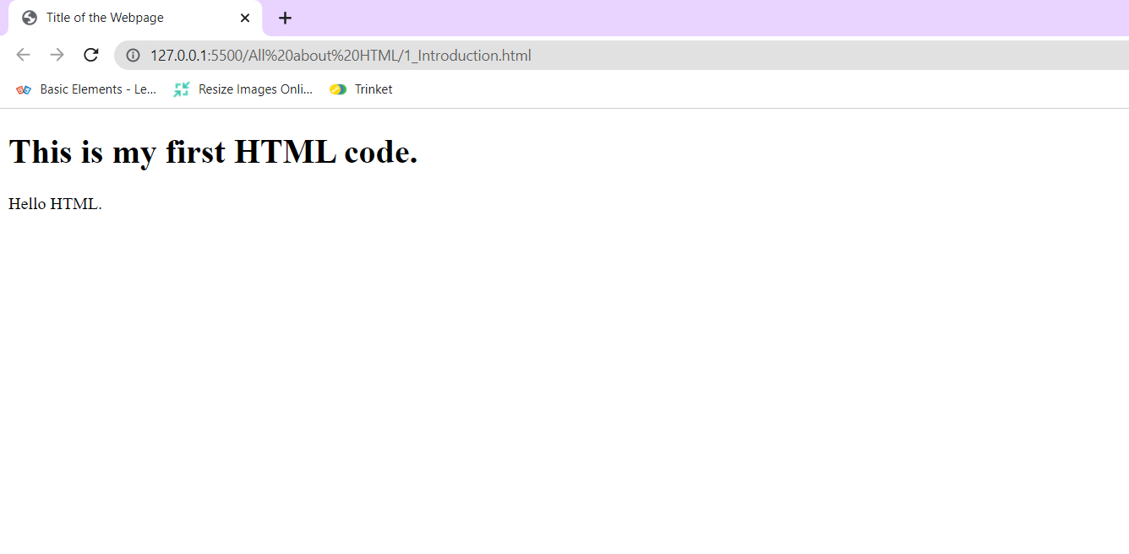
Paragraph
Heading
- What is HTML Element?
A HTML Element define by the starting tag, Content, Closing tag.
<tagname> Content goes here... </tagname>

Example:
<h1>My First Heading</h1>

Note:
<h1>: Starting tag
My First Heading: Content
</h1>: Closing tag

